**Kashyapa**

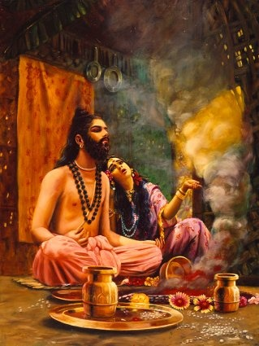

Kashyapa was an ancient sage (rishis), who is one of the Saptarshis in the present Manvantara; with others being Atri, Vashishtha, Vishvamitra, Gautama, Jamadagni, Bharadwaja.

He was the father of the Devas, Asuras, Nagas and all of humanity. He married Aditi, with whom he fathered Agni, the Adityas, and most importantly Lord Vishnu took his fifth Avatar as Vamana, the son of Aditi, in the seventh Manvantara.With his second wife, Diti, he begot the Daityas. Diti and Aditi were daughters of King Daksha Prajapati and sisters to Sati, Shiva's consort. Kashyap received the earth, obtained by Parashurama's conquest of King Kartavirya Arjuna and henceforth, earth came to be known as "Kashyapi".

He was also the author of the treatise Kashyap Samhita, or Braddha Jivakiya Tantra, which is considered, a classical reference book on Ayurveda especially in the fields of Ayurvedic pediatrics, gynecology and obstetrics. It can be safely assumed that there were many Kashyaps and the name indicates a status and not just one individual.

### History

Kashyapa is also known as Kasyapa or Kacchapa, which means "turtle" in Sanskrit. This sage is accredited as the author of several hymns and verses in the Rig Veda. His family of students are also believed to be the authors of the second verse and several other hymns of the eighth and ninth mandala of the Rig Veda.  
  
The Brihadaranyaka Upanishad mentions Rishi Kashyapa along with other ancient and powerful sages such as Atri, Vasishtha, Vishwamitra, Jamadagni, Bharadwaja and Gautama. He features in Patanjali's ancient Bhashya on the verses of Panini, in the [Ramayana](https://www.dollsofindia.com/read/ramayana.htm) and Mahabharata and also in Puranic literature.

­**Family**

Though Kashyapa features prominently in several Hindu scriptures, texts and legends, there is no one consistent tale about his birth and early life. Some legends exalt him as the father of all Gods, men and demons and some even say that he is the Kurma avatara of Lord Sri Maha Vishnu.

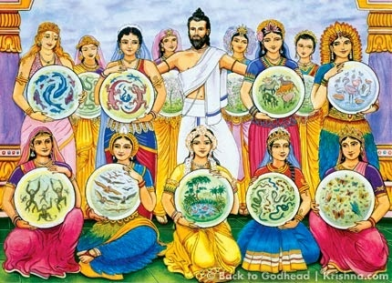

According to the Vishnu Purana, Kashyapa married the thirteen daughters of King Daksha, namely, Aditi, Diti, Kadru, Danu, Arishta, Surasa, Surabhi, Vinata, Tamra, Krodhavasha, Ira, Vishwa and Muni. The Vishnu Purana and the Vayu Purana give him the status of the father of the Devas, Asuras, Yakshas, Dravidas and all the other living creatures.

In one version, with Aditi, he fathered Surya (the Sun God) or alternatively Agni (the God of Fire) and the Adityas. In another version, Vamana (an avatara of Vishnu) is the child of Aditi and Kashyapa. The Rishi is also said to be the brother-in-law of Dharma and Adharma.

**In Hindu Texts**

Various Hindu texts give very different accounts of Rishi Kashyapa's life and time.

* According to the Ramayana, he was married to the eight daughters of Daksha, while in the Mahabharata and Vishnu Purana, he married all the thirteen daughters of Daksha. The daughters' names are also different in both the versions.
* Some legends describe him as the son of Marichi and a descendant of the Suryavansha (the Solar Dynasty). Yet others say that he was a descendant of Uttamapada, who married Daksha's daughters. Lesser heard legends state that he was a descendant of Hiranya Kashyapa.
* According to some legends, Kashyapa is believed to have drained the Kashmir valley, so as to make it utterly uninhabitable. This could probably correspond to a Buddhist legend, where Manjushri drained Nepal and Tibet. Here, the concept of "draining" could mean removing the stagnant waters of ignorance and spreading knowledge and wisdom throughout the valley.
* The Sindh city of Multan in present-day Pakistan, also referred to as Mulasthana, was called Kashyapapura in some ancient legends. Some associate Kashyapa as River Indus in the Sindh region. Some other legends state that Kashyapa reclaimed that land from a huge lake and that his school was based there. The land was ultimately named after him as well. However, there is no official record to prove these and similar other theories.

### Kashmir

It is believed that Kashmir, situated in the northern Himalayan region of India, got its name from Rishi Kashyapa. Some experts aver that this may have been the shortened version of "Kashyapa Mir" or the "lake of the sage Kashyapa". It could have also been derived from "Kashyapa Meru", or the "sacred mountains of Kashyapa".

Interestingly, in ancient Greek texts, this land has been linked to the expedition of Alexander the Great and had been called "Kasperia", probably a short form of "Kasyapamira". Further, the word "Kaspapyros", which appears in Greek geographer Hekataois text, traces the path of the Indus River from the mountains, where it drained in the sea. Kaspa-pyrus may have been derived from "kasyapa-pur" or the "city of Kashyapa".

### In Buddhist Texts

According to Buddhist Pali canonical texts such as Digha Nikaya and Tevijja Sutta, the Buddha used to have discussions with the Vedic scholars of his time. The Buddha named ten Rishis, calling them "early sages" and makers of the ancient verses that were collected and chanted during his era. Among these ancient sages is Kassapa, which is the Pali spelling of "Kashyapa".

**Literary Works**

Kashyapa is accredited as the author of innumerable texts in the medieval era. The following are some treatises named after the Rishi or attributed to him:

* Kashyapa Samhita, also called Vriddhajivakiya Tantra or Jivakiya Tantra, is a reference book on Ayurvedic paediatrics, obstetrics and gynaecology. Revised by Vatsya, this is a tutorial, jointly written by the sage and his student, Vriddhajivaka.
* Kashyapa Jnanakandah or his "book of wisdom", is a 9th century text, used in Vaishnavism.
* Kashyapa Dharmasutra, which is now lost, is supposed to be a very ancient text. Its existence is inferred from quotes and citations by ancient Indian scholars.
* Kashyapa Sangita, again a very old text, is now lost to us. This was supposed to be a treatise on music and is quoted by Shaivism and the Advaita scholar, Abhinavagupta. Here, Kashyapa explains the viniyoga (meaning and uses) of each rasa and bhava. Another music scholar named Hrdanyangama, mentions the Rishi's contributions to the theory of alankaras in Indian music.
* Kasyapasilpa, also referred to as Amsumad Agama, Kaspiya or Silpasastra of Kasyapa, is a Sanskrit treatise on architecture, iconography and the decorative arts.